**Switchover section**

Search for database in All Targets screen

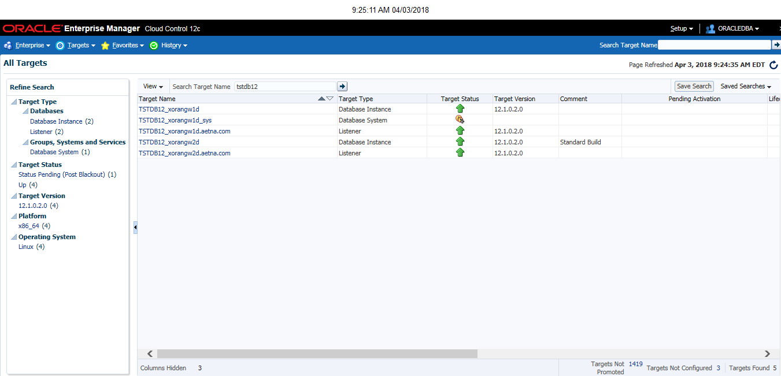

Choose the standby database (can use the primary as well) and go to the Data Guard Administration page under the Availability pull down.

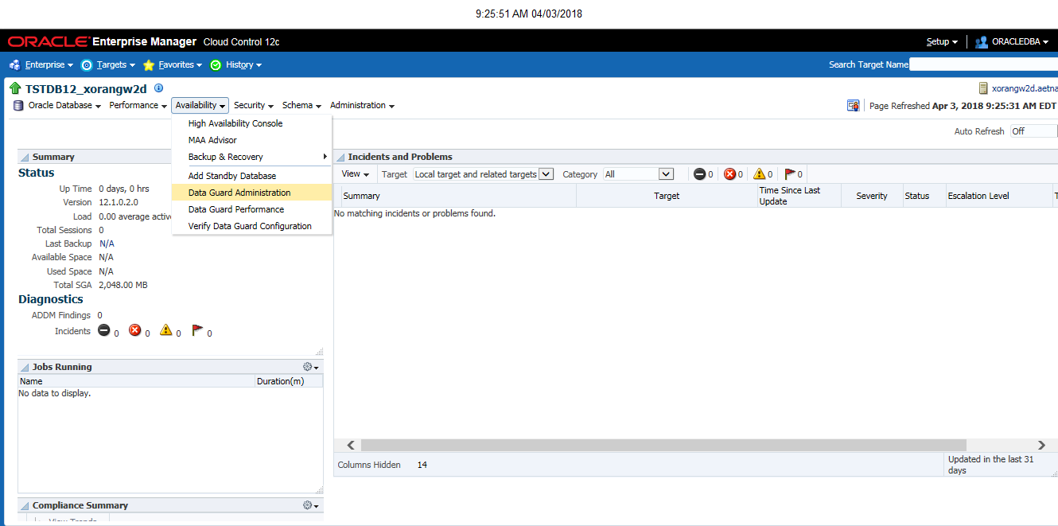

Login to the database with SYS credentials. Locked#99999

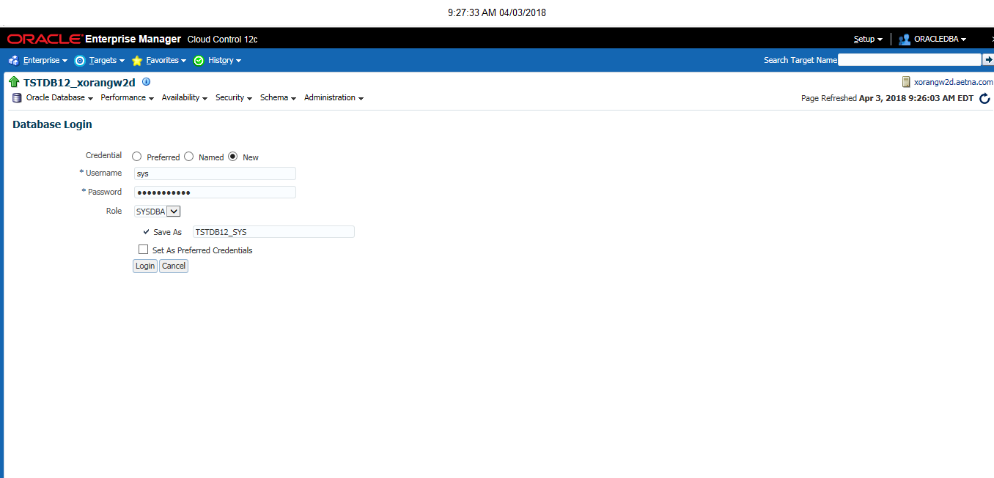

Select the standby database and press the switchover button

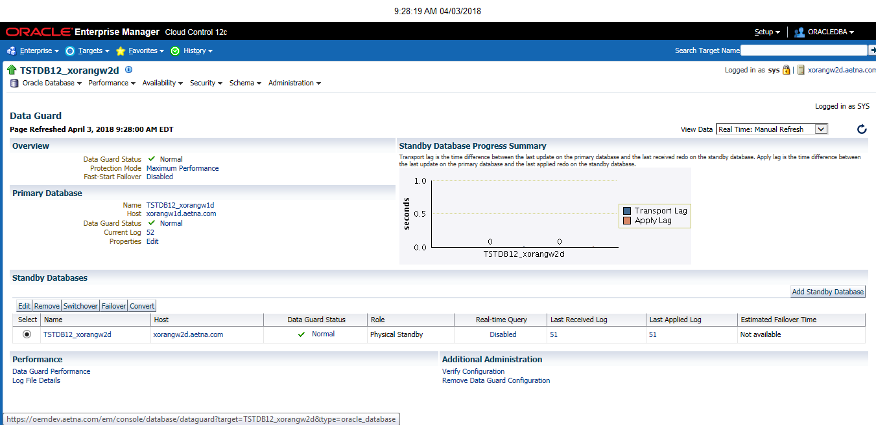

Select the SSH_ORACLE_CREDENTIALS for the standby host credentials

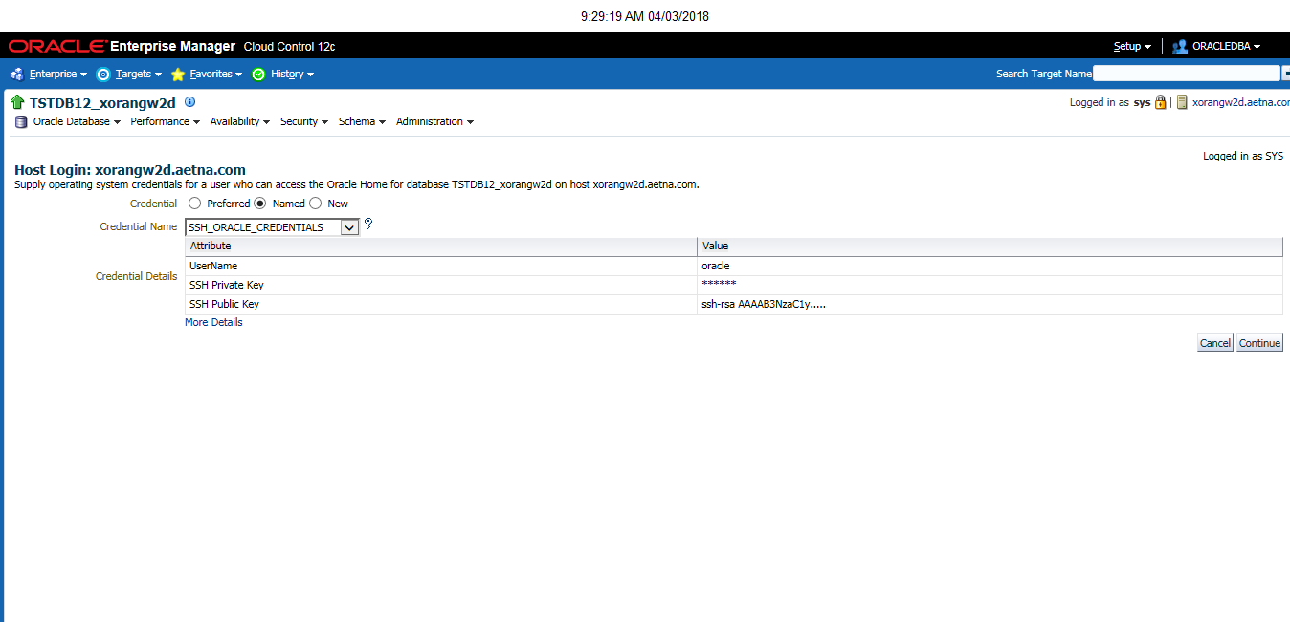

Select the SSH_ORACLE_CREDENTIALS for the primary host credentials

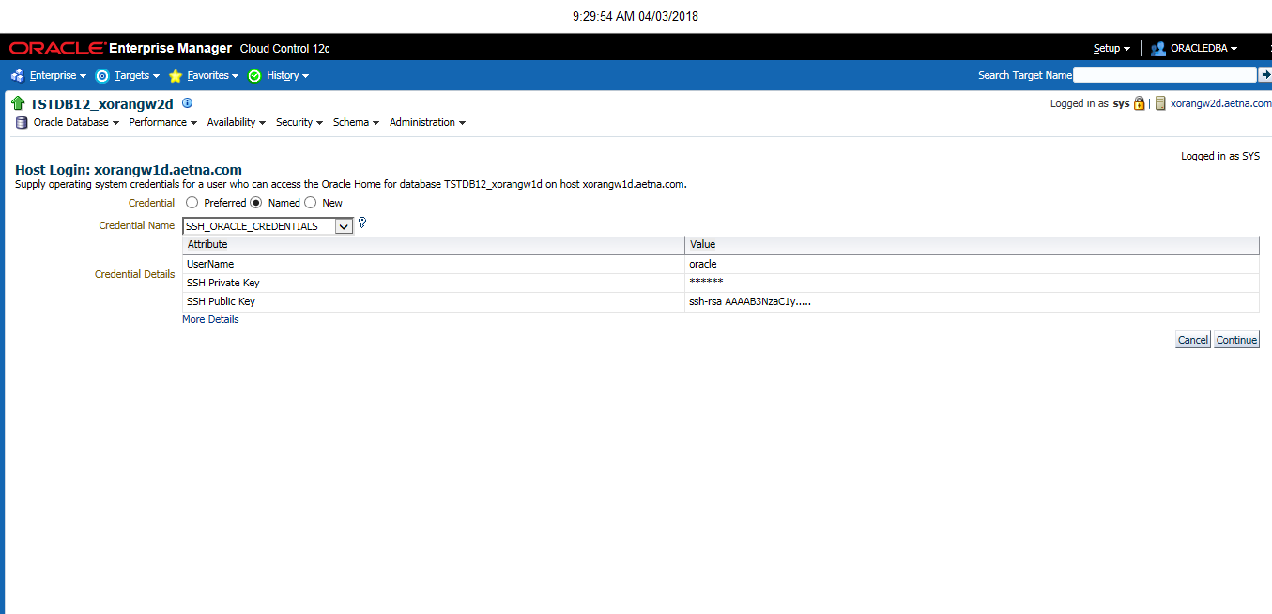

Select Swap Monitoring Settings and Transfer Jobs, then press yes

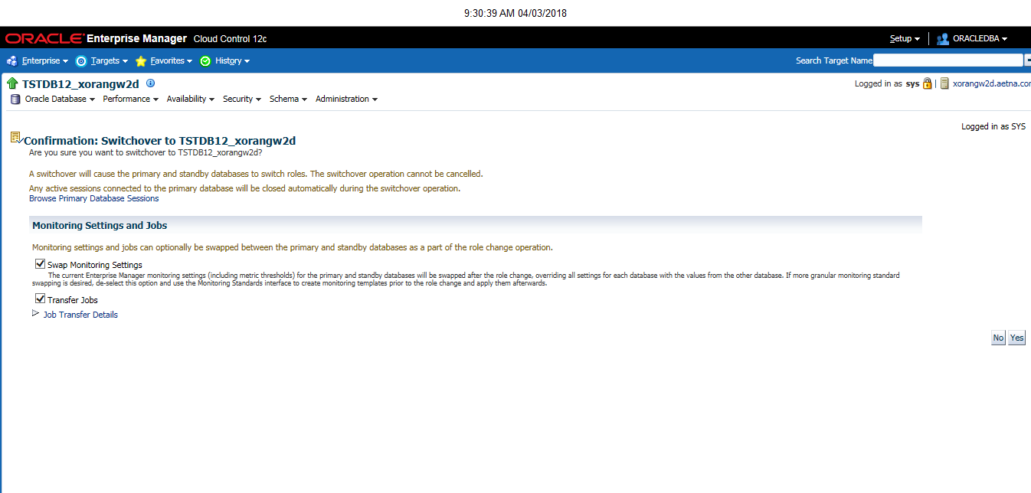

Switch over progress screen appears

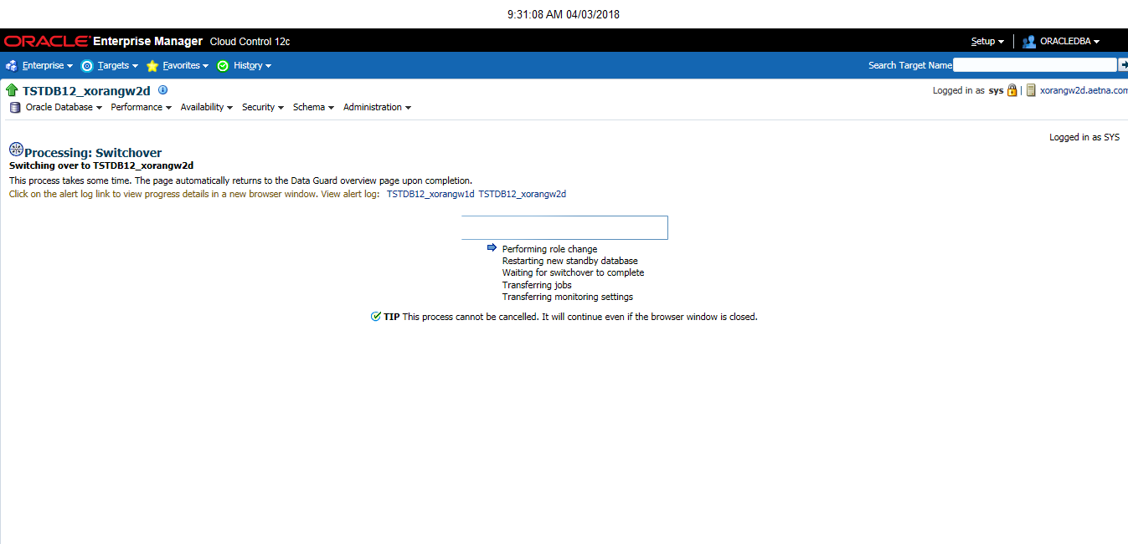

Switchover complete

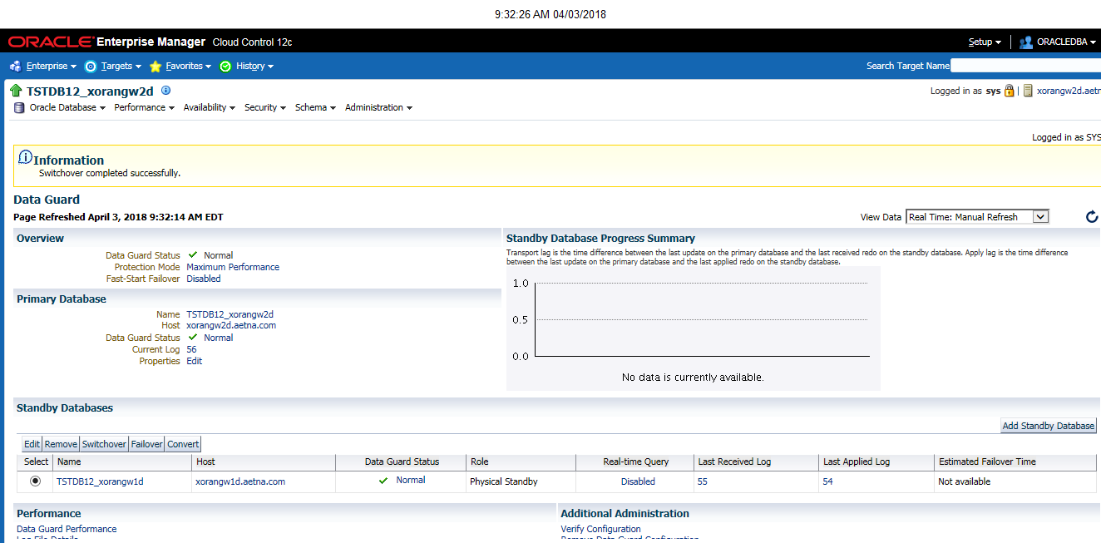

**JOBS section**

Go to Job activity for the new primary and modify the STDBY_ARCHVE_LOG_PURGE to run on the new standby

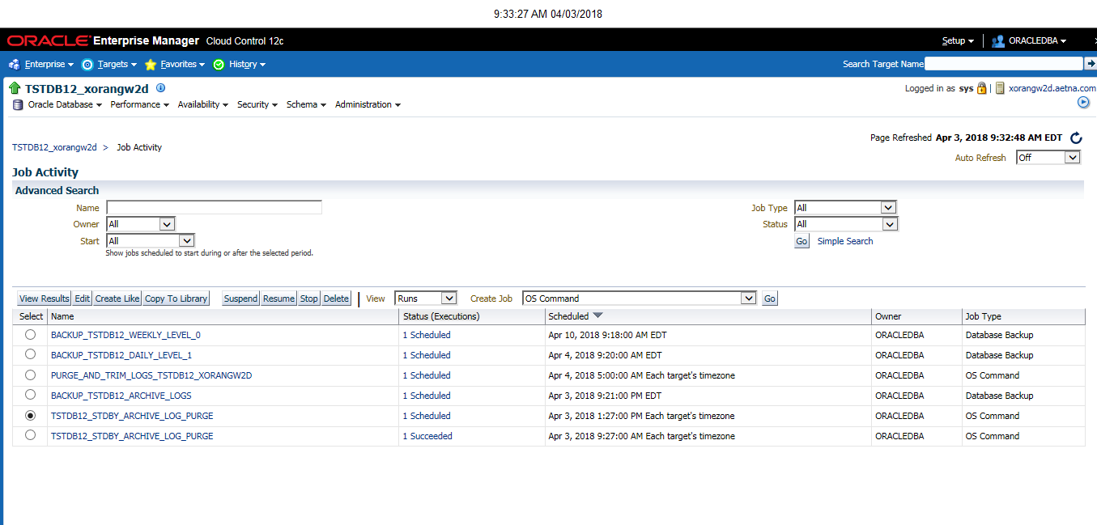

Remove the new primary database and add the new standby database

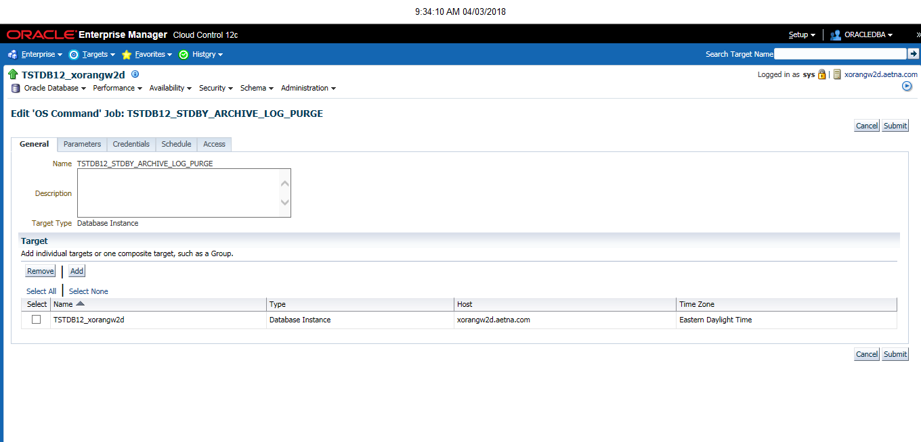

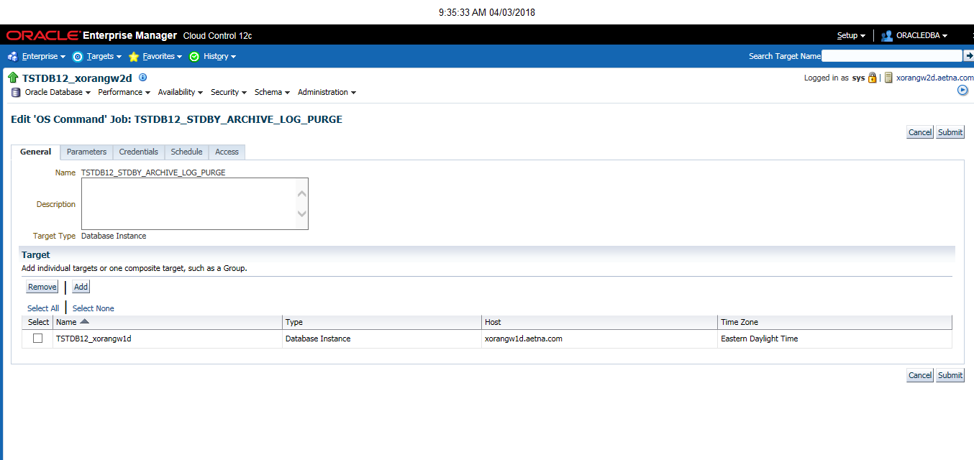

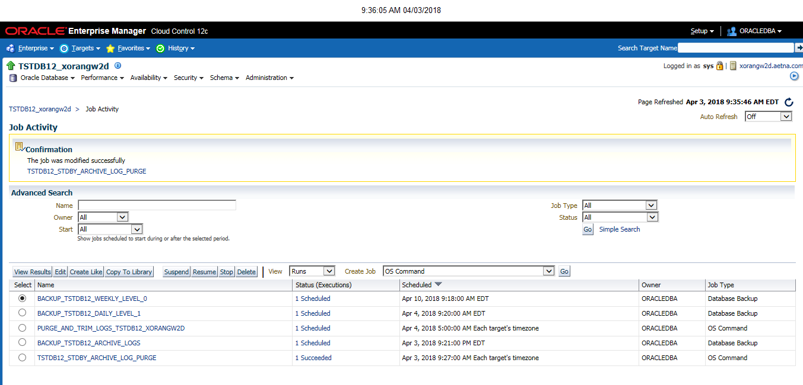

Go to the Job activity screen for the new standby and modify the CHANGE_DATAGUARD_SYS_PWD job to execute on the new primary.

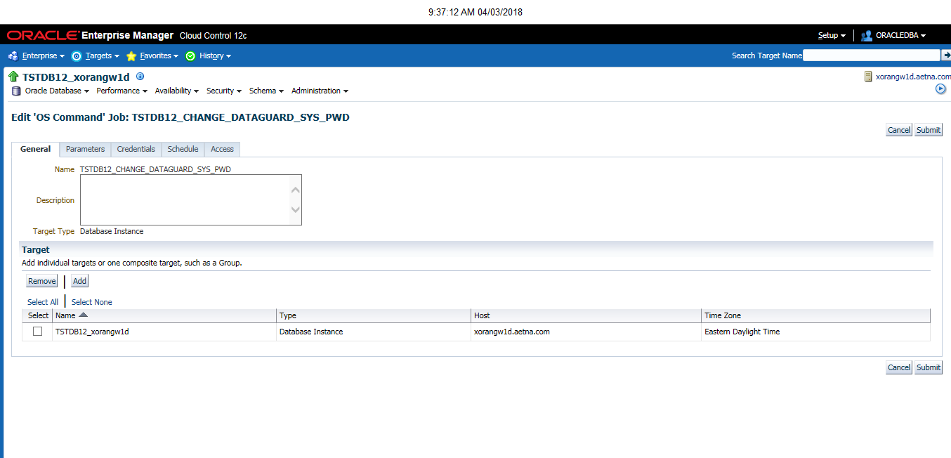

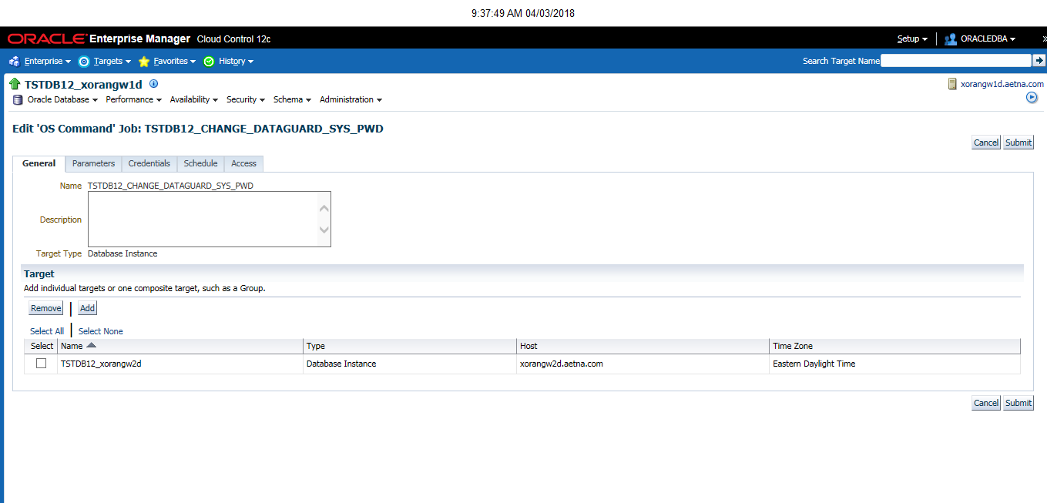

Go to recovery catalog settings for the new primary under the Availability pull down and make the recovery catalog assignment.

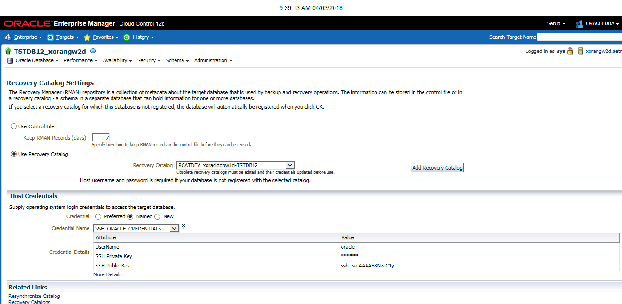

Recreate the database backup jobs to pick up the correct connect string for the new primary database.

Below existing backup settings. Model new ones similar. Stopped Existing jobs first

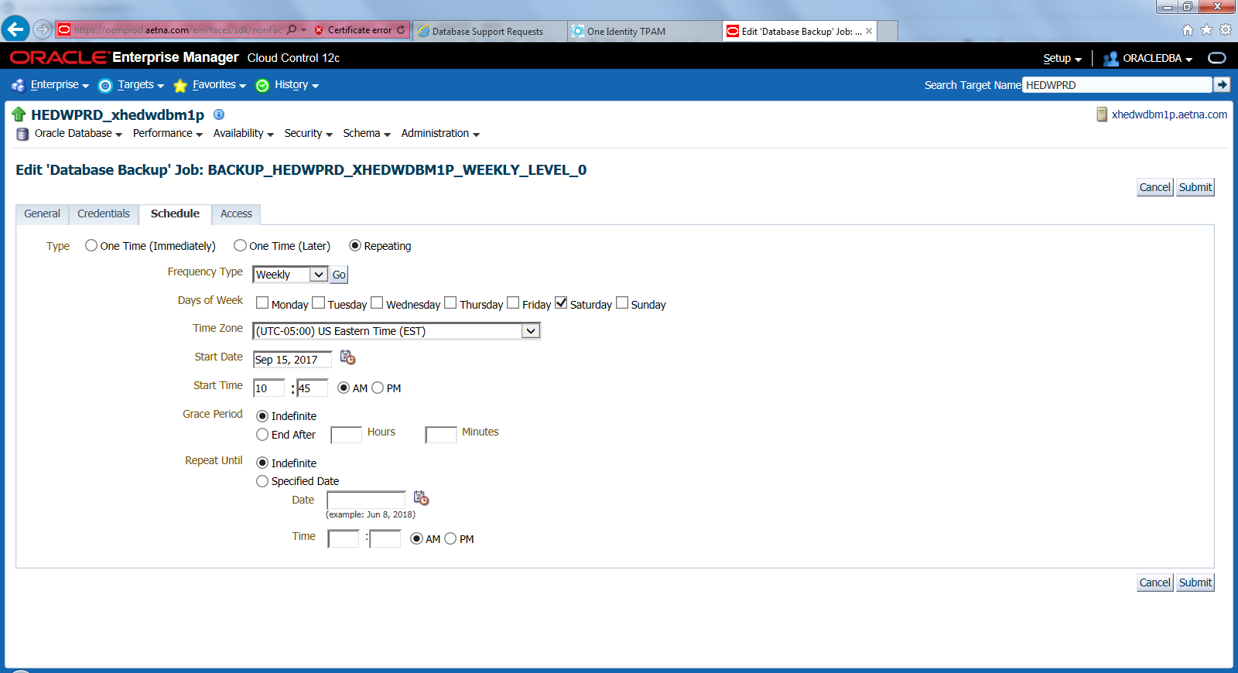

backup incremental level 0 cumulative device type sbt tag '%TAG' database;

delete noprompt obsolete device type 'SBT_TAPE';

